**Digital River**

**Release Management**

**What is SRMS (Software Release Management System)?**

* SRMS is a tool for planning, managing, deploying and auditing releases of software in UNIX and Windows environments.
* SRMS provides SOX compliance reporting of software updates and database changes.
* SRMS provides a robust set of resource management and capacity planning tools for all phases of the release cycle.
  + Business owners are able to prioritize open issues based on business needs.
  + QA is able to assign and manage testing requirement and time estimates.
  + Developers are able to manage their work priorities and time requirements.
  + Release managers can perform all required actions directly inside of SRMS.
  + Planning and capacity tools can be used independently from code management tools
* SRMS provides workflow management tools for both the DBA and Unix teams for requests that are part of a release.
* SRMS provides detailed reporting and metrics to inform and improve the development life cycle.

**Features**

**Independent Release Planning Tools**

* Works directly with external ticketing systems
* Estimate Development and QA hours
* Development and QA risk tracking
* Current and Expected QA coverage
* QA tester assignment
* Development reviewer assignment
* Capacity planning
* Ticket severity and priority control

**Release Process**

* Ensure that all changes have been applied and verified before the release can be staged or promoted to production
* QA verification enforced for all changes
* Optional user acceptance testing
* Platform configurable software deployment methods
  + Code Promotion
    - Checkout code from revision control system
    - Build and compile code if required
    - Deploy to appropriate environment
  + Rollback code to previous version
  + Bounce application servers
  + Switch active and inactive instance
* Support for multiple testing environments (systest, integration, staging, production)
* Support for multiple production environment (active, inactive)
* Peer review enforcement for standards compliance
* Automated code promotion
* Ability to switch active/inactive production environments
* Ability to bounce servers by environment
* Direct integration with external ticketing system
* **Role based access control**
  + Roles for functional groups
    - Developer
    - QA
    - QA Manager
    - Release Manager
    - Business Owner
    - Admin
    - DBA
    - Unix
    - Security
  + Roles assignable both globally and for specific platforms
  + Controls over who can affect production environments
  + Prevents developers from reviewing and promoting their own code
* Group notification of pending tasks
* DDL creation GUI for Development
* DBA workflow
  + Easy access to DDL/DML
  + Integration with release process to facilitate communications of work needs
  + Ability t*have DDL applied automatically during release process *
  + **\*Unix workflow**
  + Easy access t*Scripts and Instructions
  + Multiple versions of Scripts and Instructions based on environment
  + Integration with release process t*facilitate communications of work needs
  + Direct access t*Scripts and Instruction for easy deployment t*release servers
* **Unix/DBA** deployment scheduling make sure critical task are done at the right time
* Important release stages executed out of band t*improve usability
* Email notification of job completions
* Inter and Intra platform ticket dependencies t*assure associated code deployed together
* Release emails
* Hot deployment of releases for urgent code changes affecting immediate production issues
* Require all tickets are verified in production and closed in the external ticketing system

**Reporting**

* Cancelled ticket report provide ticket status reconciliation between SRMS and external ticketing systems
* Issues report shows tickets that required additional resources during testing
* QA defect removal efficiency report
* Tracking and reporting of all software released for all environments
* Release statistics showing number of releases, files/lines add/removed, tickets addressed
* Reporting on release date changes, tracking reasons and frequency
* Production database change reporting (oracle and MySQL changes)
* RSS feeds for most reports

**Systems tasks**

* Roles based access control
* Highly configurable platform setup
* Flexible environment setup
* Integrated help system

**What is Release Management Change?**

* Release Management Changes refer to software code changes that are related to a release
* Release Management changes follow a similar process flow as the Normal Change process
* Release Management changes require both Technical approval and CAB approval prior to their deployment

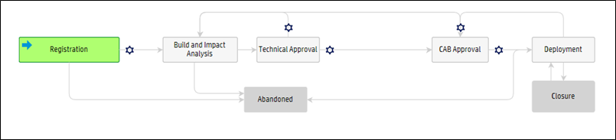

**Key Terms**

**Change Requester**

* The Change Requester field is used to identify the person requesting the activity.

**Change Assignee**

* The Change Assignee is usually the person who implements the Change. This role validates the change, updates the Change and will eventually close the Change with the appropriate closure code.

**Technical Approver**

* This role is a member of group that is given the authority to approve a change. The Technical approver is the manager of the person who is the Change Requester/Assignee.

**Change Manager**

* The Change Manager controls the lifecycle of all Changes. Helps to ensure that all changes are implemented with minimum disruption to Digital River’s production environment. Provides a single point of contact and is responsible for coordinating all change functions within Digital River.

**Change Advisory Board (CAB)**

* The Change Advisory Board is a group of people that support the assessment, prioritization, authorization and scheduling of changes. A change advisory board is usually made up of representatives from all areas within the IT service provider; the business; and third parties such as suppliers.

**Creating a Release Management Change**

**Login into HP Service Manager**

* Go to http://sm.digitalriver.com
* Login using your standard Network Credentials
* If unable to login, use SRC to open an incident ticket http://src.digitalriver.com

**Your login screen will default you to your [To Do] Queue**

* On the far left of your screen locate and click [Change Management]
* Click [New]

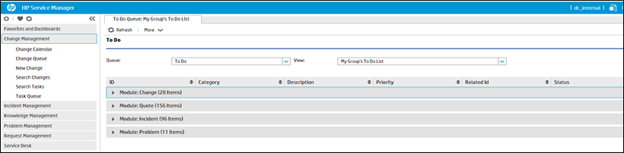

**Category & Subcategory**

After clicking [New] your screen will display

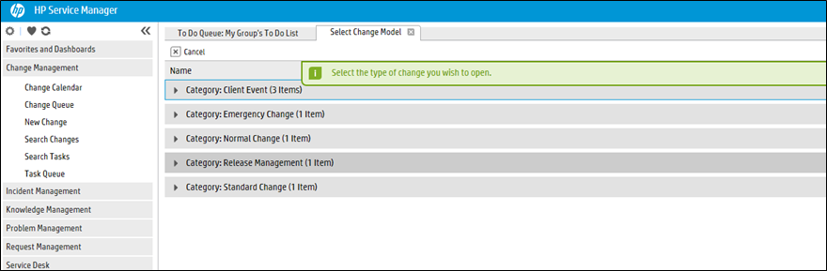

**Selecting Category & Subcategory**

It’s time to create your change record

* Click the arrow on the left of the Category Normal Change
* Click the arrow on the left of the SubCategory Normal Change
* Click Release Management
* This will launch the Release Management Change form that will enable you to Register your change

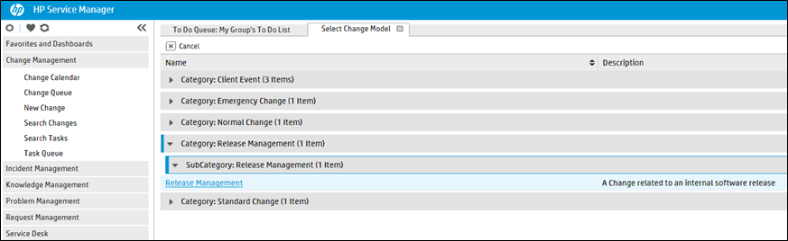

**Registration and Categorization**

* Populate all of the required fields (Title, Change Requester, Reason for Change, Service, Affected Configuration Item, Assignment Group, Assignee Name & Description), the required fields are identified with a red *
* The Description field is the place for you to provide as much detail as possible for your change

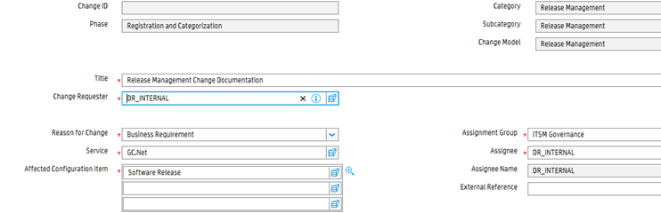

**Registration and Categorization**

There is a fill button located on the right side of each required field

* You can also utilize the fill button as a search, you can type a partial name in the field and then click the fill button
* Even if you know the exact name that you want to enter, you must click the fill button to reconcile the name

When finished populating the Required Fields in the Registration and Categorization phase click [Save]

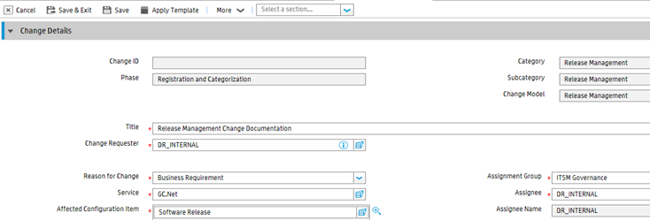

**Build and impact analysis – cont…**

Still in the Build and Impact Analysis phase

* Populate all the required fields
* The Scheduled Deployment Start and End will reflect the window of time for how long the change will take to be implemented
* The Back Out Plan are the documented steps to how we would roll back the code and/or changes that were deployed into production
* The Test Plan section need to show the documented steps to how we validated that this change is ready to be deployed into production and show that a plan is in place if we encounter issues

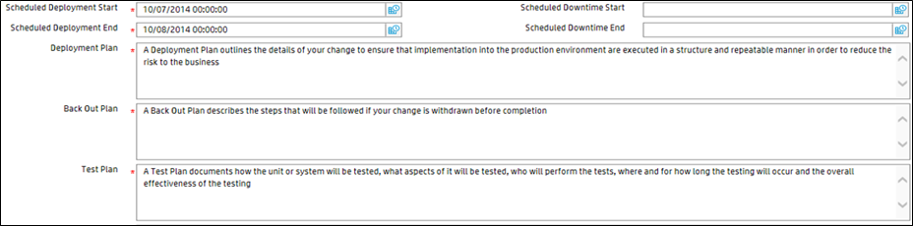

**Build and impact analysis – cont…**

At this point your change is ready for your manager’s approval

Click the [Request Technical Approval] button

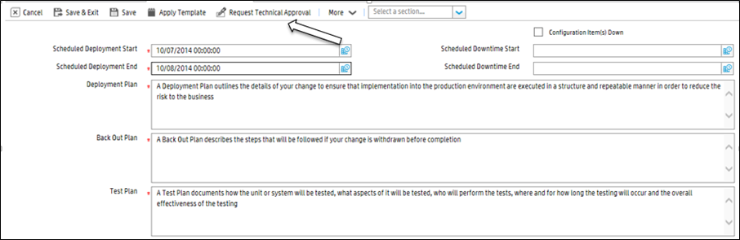

**Technical Approval**

The record is now in the Technical Approval phase

* In this phase your manager is going to review approve or deny your change

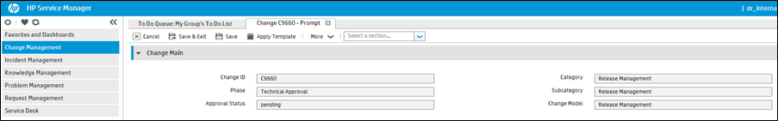

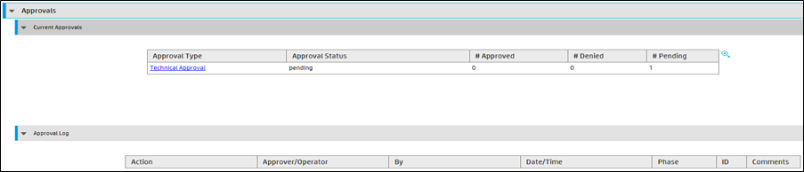

**Technical approval**

Technical Approval phase

* You will need to wait for your manager to approve the change
* Happy Path – your manager approves
* Your change goes to CAB approval

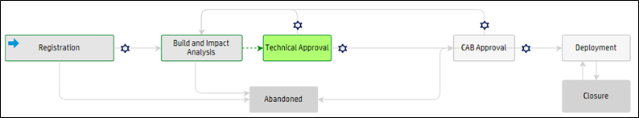

**CAB approval**

* The CAB Approval phase requires you or a member of your team to attend the CAB meeting to represent your change
* Failure to have representation during the CAB will result in your change being **denied**
* During the meeting you will discuss the specifics of your change including costumer impact, communication needs, and the risk to the business if your change is or is not implemented
* After you have represented your change at the CAB you will be informed during the CAB that your change was approved or denied
* You cannot implement your change until it is in the Deployment phase

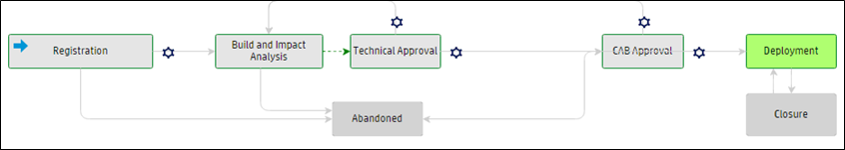

**Deployment**

At this point your change has gone through all the needed approvals and is ready to be deployed

* If you do not want to go forward with your deployment you can select Abandon from the [More] menu
* Abandon will allow you to close your change
* To move forward with your deployment select [Close]

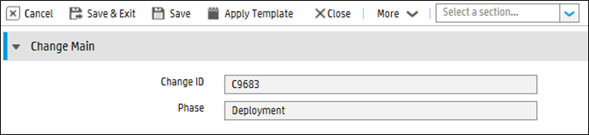

**Closure Code and comments**

Utilizing the Closure Code field you will select from the following codes:

1 – Successful

2 – Successful (with problems)

3 – Failed

4 – Rejected

5 – Withdrawn

6 – Cancelled

7 – Backed Out

Utilizing the Closure Comments field

* This is a free text field that you will utilize to describe your implementation
* Use the Closure Comments field to express Validation of your change
* Any closure status other than Successful will trigger your Standard Change template to be removed from a pre-approved template and you will need to open future changes a Normal Change

**Closure code and comments**

At this point you are in the Closure Code and Comments phase

* Select the appropriate Closure Code utilizing the dropdown arrow
* Use the Closure Comments field to document the results of your implements
* Make sure the Closure Code fields are filled out and click [Finish]

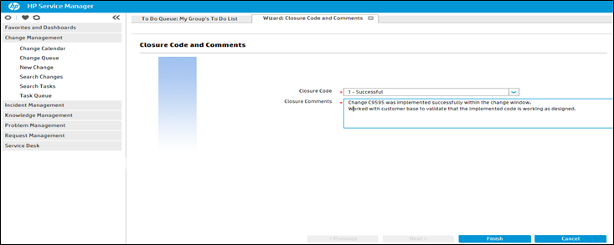

**Closure**

* Whether your change was Successful, Successful with Problems, Failed, Rejected, Withdrawn, Cancelled or Backed Out you will receive a message indicating your change is now closed

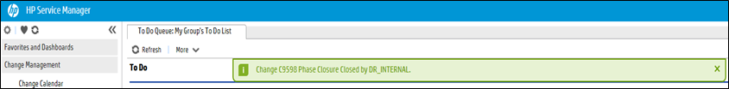

**Creating a Normal /expedited Change**

Normal Expedited Change

* An Expedited Change is a Normal Change that is labeled Expedited because it is implemented prior to a CAB review
* Expedited changes or not registered as an Emergency Change but their implementation is urgent enough that they cannot wait for the next available CAB meeting for their approval
* To Expedite a change, check the Expedited Change box during the Registration and Categorization phase
* A Normal Expedited Change will proceed through all the required steps of the normal change management process and will be reviewed by the Change Advisory Board (CAB) after deployment

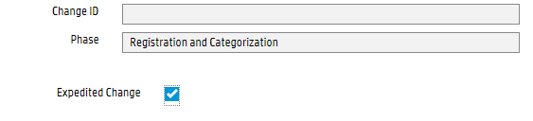

**Expedited Normal change**

Expedited Normal Change

* Follow the Normal Change process fill in all required fields
* Follows the path of the Normal Change to the Technical Approval Phase
* After Technical Approval you go to the Deployment Phase
* Implement your change
* You are required to represent your Change at the next available CAB meeting
* After CAB review close your Expedited change
* Refer to slide 17 for closure code and comments

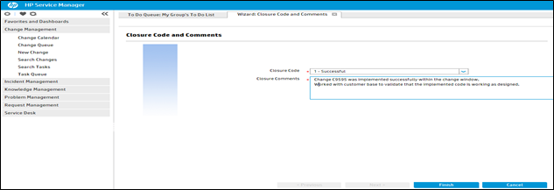

**Release Control Process**

Login into HP Release Control

* Go to http://rc.digitalriver.com
* Login using your standard Network Credentials

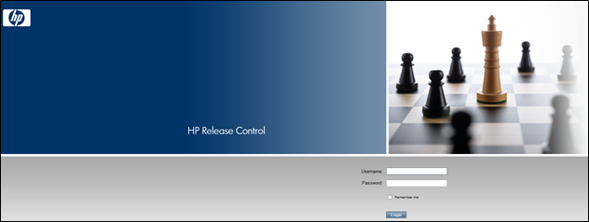

* If unable to login to Release Control, send an email to changemanagement@digitalriver.com

**Release Control detail**

**Change Types in RC include**

* Normal Change - A Change that could have an impact in production
* Emergency Change – A Change to restore service in response to a Tech Center P1 or P2 incident
* Standard Change – A pre-authorized change this is low risk and follow a procedure or work instruction
* Release Management – A Normal Change that is preformed by a DR release management team
* Client Event
* Common Events – Track the global activities that impact many clients’ business, promotions and sales
* Promotions – Tracks any marketing efforts designed to drive additional, new or large amounts of traffic to the site
* Site Launch – Tracks the launch of new sites, large scale rebranding, or other wholesale changes or update to a site

**Release Control (RC)**

* **Release Control is also known as:**
* Change Calendar
* Release Calendar
* Event Calendar
* RC
* RC is the release calendar used for all DR activity
* RC is read only, the data cannot be modified
* Additional views can be created to meet specific criteria
* RC data is fed from Service Manager
* The data in RC is Change Management related activity
* The expectation is for all change implementers is to review the Release Control prior to scheduling their activity

**Default view**

* This is the default view you will see once you login
* This shows you the weekly view of changes that are scheduled to be implemented
* At the bottom of the window you will see an overview of the highlighted change

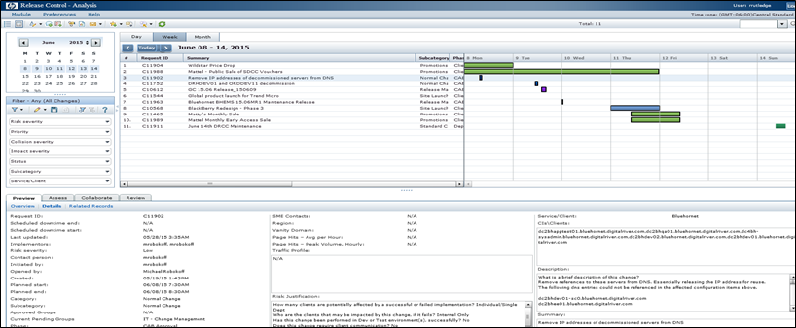

**Day view**

* Click on the Day tab this will show you the changes that are scheduled to be deployed for that specific day
* The Subcategory will provide the type of change that is being deployed

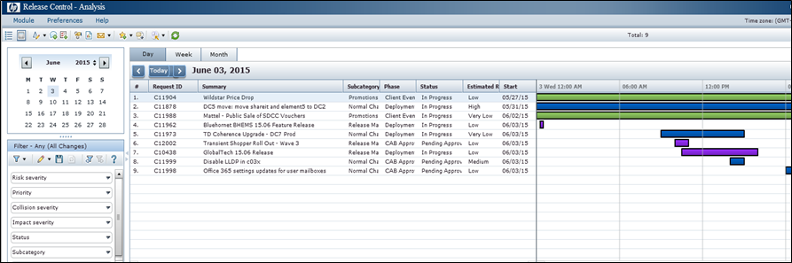

**Detailed overview**

**Day View**

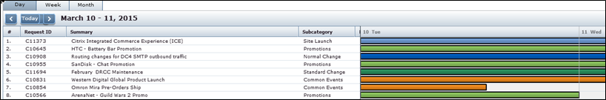

**Week View**

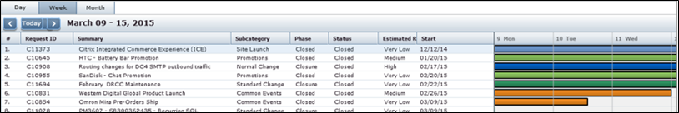

**High level overview**

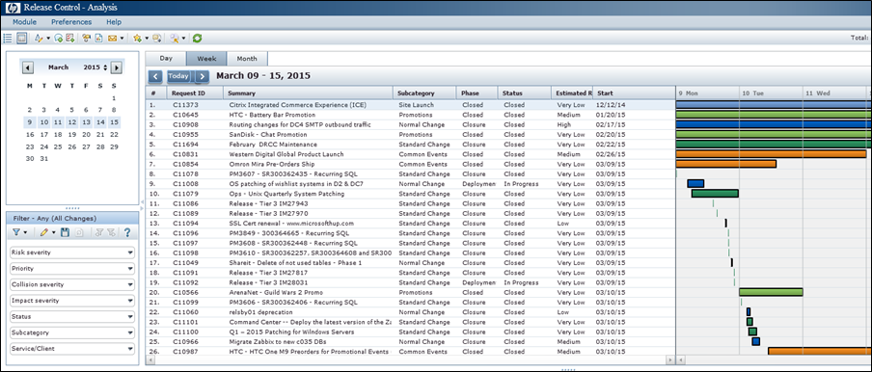

**Change Details tab**

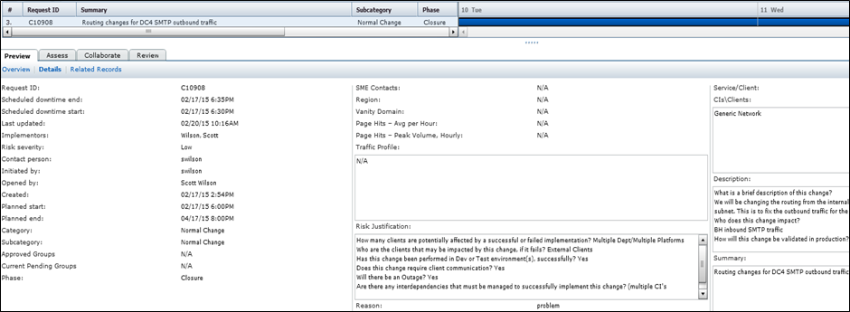

**Same data in Service Manager**

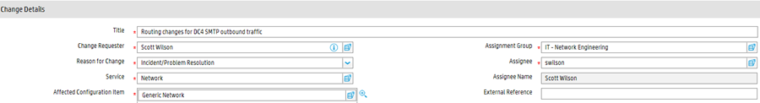

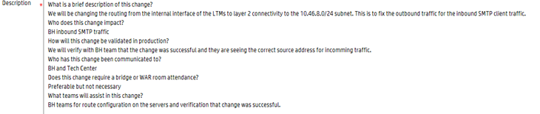



**Freeze Periods/blackout dates**

**RC is has the ability to display dates that fall under change restrictions**

* DRCC Monthly Maintenance window – Second Sunday of each month
* Enterprise Freeze – No Normal or Standard changes are allowed to be made in production during this period
* Infrastructure Freeze - All Normal and Standard changes will require elevated approval from the CIO
* Emergency changes can be deployed into production if they are in response to a Major (Priority 1 or 2) Incident

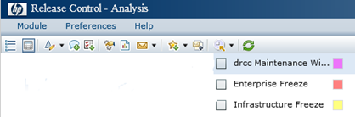

**Blackout dates**

* Click on the Select Time Period tab this will show you the changes that are scheduled to be deployed during a black out
* Check off the blackout filters that you would like to see
* The blackout filter will display the color coded bars on the calendar that corresponds to the blackout dates
* This slide shows the black out for a DRCC Maintenance Window

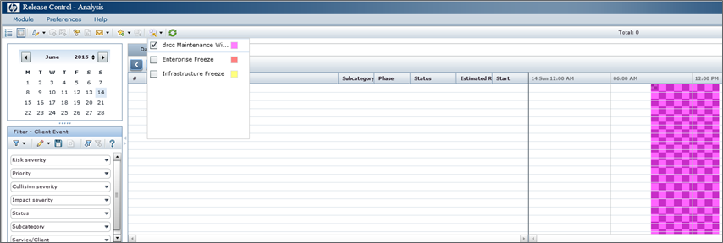

**FILTERS**

My Filters tab

* These views represent the views and settings that each individual customer creates on their workstation

Action Items

* We are not utilizing this category

General tab

* These views represent the views that the system administrator has created

Note

* The date drives the information of the change activity that is available to be represented in the view
* You will be defaulted to the General, Any view

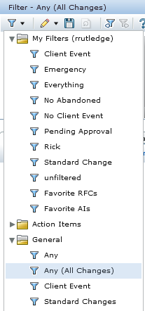

**Changing the preferences**

You can change the fields that are displayed and the order in which they are displayed under the Preference option

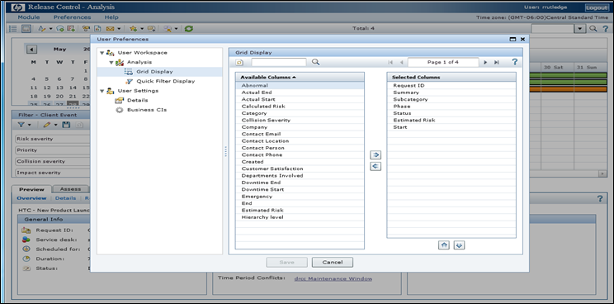

**Utilizing filters**

You can use the filters on the left side pane to filter the changes down to a set that is of more interest to you

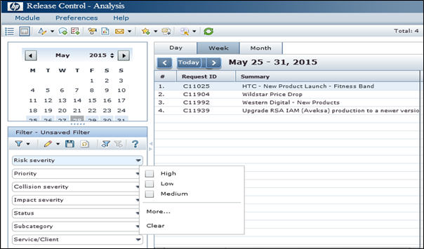

**Change Exception Process**

**Any change requested during a hypercare period will be considered an Elevated Change and must follow the appropriate Elevated Change process listed below.**

For IT (infrastructure) Changes

* Create the change per the Change process. (link here)
* After Technical Approval is obtained, Elevated Approval must be obtained.
* During the Yellow periods, obtain Elevated Approval from Robson Snyder, Ryan Douglas, or. They will add their approval via the Service Manager tool.

For Release (Code/Data) and Site Deploy Changes

<http://confluence/display/RlsMgr/Emergency+Releases>